ROC Curve, AUC,
Regularization and Cross-Validation
5W1H Concepts + Integrated Vehicle Failure Prediction Case Study
Trainer-ready learning module with runnable Python code, dataset, model comparisons, threshold analysis, and validation strategy selection
Business domain | Automotive predictive maintenance
Prediction target | Vehicle failure within the next 30 days
Core learner outcome | Choose a model and validation method using safety and business impact—not accuracy alone

Important: This is a synthetic learning case study, not a documented deployment by a named automobile company.

1. Learning Objectives
- Explain ROC Curve and AUC using What, Why, Who, When, Where, and How.
- Distinguish a model’s ranking quality from a specific classification threshold.
- Explain how L1 and L2 regularization control model complexity and overfitting.
- Select the correct cross-validation strategy for imbalanced, grouped, or time-ordered data.
- Build and evaluate a vehicle-failure classifier using a leakage-safe scikit-learn Pipeline.
- Translate accuracy, recall, false positives, false negatives, and ROC-AUC into maintenance decisions.

2. Module Map
Section | Topic | Practical outcome
3 | ROC Curve - 5W1H | Understand threshold trade-offs between caught failures and false alarms.
4 | AUC - 5W1H | Compare ranking quality without selecting one threshold.
5 | L1 and L2 - 5W1H | Control coefficient size and feature complexity.
6 | Cross-validation - 5W1H | Estimate how the model may perform on unseen data.
7-13 | Vehicle failure case study | Implement, compare, validate, and interpret the models.
14 | Exercises and review | Check conceptual and practical understanding.

Core idea
Accuracy answers “How many predictions were correct?” ROC-AUC answers “How well did the model rank risky vehicles above normal vehicles across thresholds?” Cross-validation asks “Will this quality remain stable on different unseen samples?” Regularization asks “Can we obtain that performance with a simpler, more stable model?”

3. ROC Curve - 5W1H
ROC means Receiver Operating Characteristic. It is a graph that evaluates a binary classifier at many probability thresholds rather than at only the default threshold of 0.50.
5W1H question | Concept explanation | Vehicle-failure interpretation
What? | A graph of True Positive Rate against False Positive Rate at multiple thresholds. | Shows how many failing vehicles are detected versus how many normal vehicles are unnecessarily inspected.
Why? | A single threshold can hide trade-offs. ROC reveals the full trade-off as the threshold changes. | Management can see the safety gain and additional inspection workload before choosing an operating threshold.
Who? | Data scientists, ML engineers, risk owners, product managers, auditors, and domain experts. | Maintenance engineers and fleet-safety owners must review the curve with the ML team.
When? | After a binary classifier produces probabilities or decision scores. | After the model produces a failure-risk score for every vehicle inspection.
Where? | Fraud, medical screening, defect detection, predictive maintenance, cybersecurity, and churn. | At fleet service centres, connected-vehicle monitoring platforms, and preventive-maintenance planning systems.
How? | Move the threshold from high to low; compute TPR and FPR at each point; plot FPR on X and TPR on Y. | At a lower threshold, more risky vehicles are caught, but more healthy vehicles are flagged.

3.1 ROC Terms
Term | Formula | Meaning in the case study
True Positive Rate (TPR) | TP / (TP + FN) | Of all vehicles that actually fail, what percentage did the model detect? This is Recall.
False Positive Rate (FPR) | FP / (FP + TN) | Of all normal vehicles, what percentage were incorrectly sent for inspection?
Threshold | Probability cut-off | A vehicle is labelled risky when its predicted probability is at or above this value.

Threshold movement
A high threshold produces fewer alerts and may miss more failures. A low threshold catches more failures but creates more unnecessary inspections. ROC does not decide which trade-off is acceptable—the business and safety context must decide.

4. AUC - 5W1H
AUC means Area Under the ROC Curve. It compresses the ROC curve into one number that summarizes ranking quality.
5W1H question | Concept explanation | Vehicle-failure interpretation
What? | A number between 0 and 1 measuring the area under the ROC curve. | Measures how effectively the model gives higher risk scores to failing vehicles than to normal vehicles.
Why? | It enables quick comparison of classifiers across all thresholds. | Allows comparison of L1 and L2 models without first committing to a maintenance threshold.
Who? | Model developers, reviewers, governance teams, and business stakeholders. | Fleet analytics and safety teams use it as one model-quality indicator.
When? | During model comparison, feature experiments, tuning, and cross-validation. | Use it before deployment and during periodic model monitoring.
Where? | Binary classification where probability ranking matters. | Failure prediction, component-risk ranking, warranty-risk detection, and service-priority queues.
How? | Numerically integrate the ROC curve. It can also be interpreted as ranking probability. | AUC of 0.90 means the model will rank a randomly selected failing vehicle above a randomly selected normal vehicle about 90% of the time.

AUC range | General interpretation | Important caution
0.50 | No ranking power; similar to random ordering. | A model predicting the same score for every vehicle has AUC 0.50.
0.60-0.70 | Weak discrimination. | May be insufficient for safety-sensitive use.
0.70-0.80 | Acceptable to good discrimination. | Still requires threshold and cost analysis.
0.80-0.90 | Strong discrimination. | Check stability and data leakage.
0.90-1.00 | Excellent discrimination. | Not proof that the model is calibrated, fair, or operationally safe.

4.1 What AUC Does Not Tell You
- It does not select the production threshold.
- It does not directly show precision, recall, or the number of missed failures at one threshold.
- It does not confirm that predicted probabilities are well calibrated.
- It does not include the financial or safety cost of false positives and false negatives.
- For extremely rare positives, also inspect the Precision-Recall curve and Average Precision.
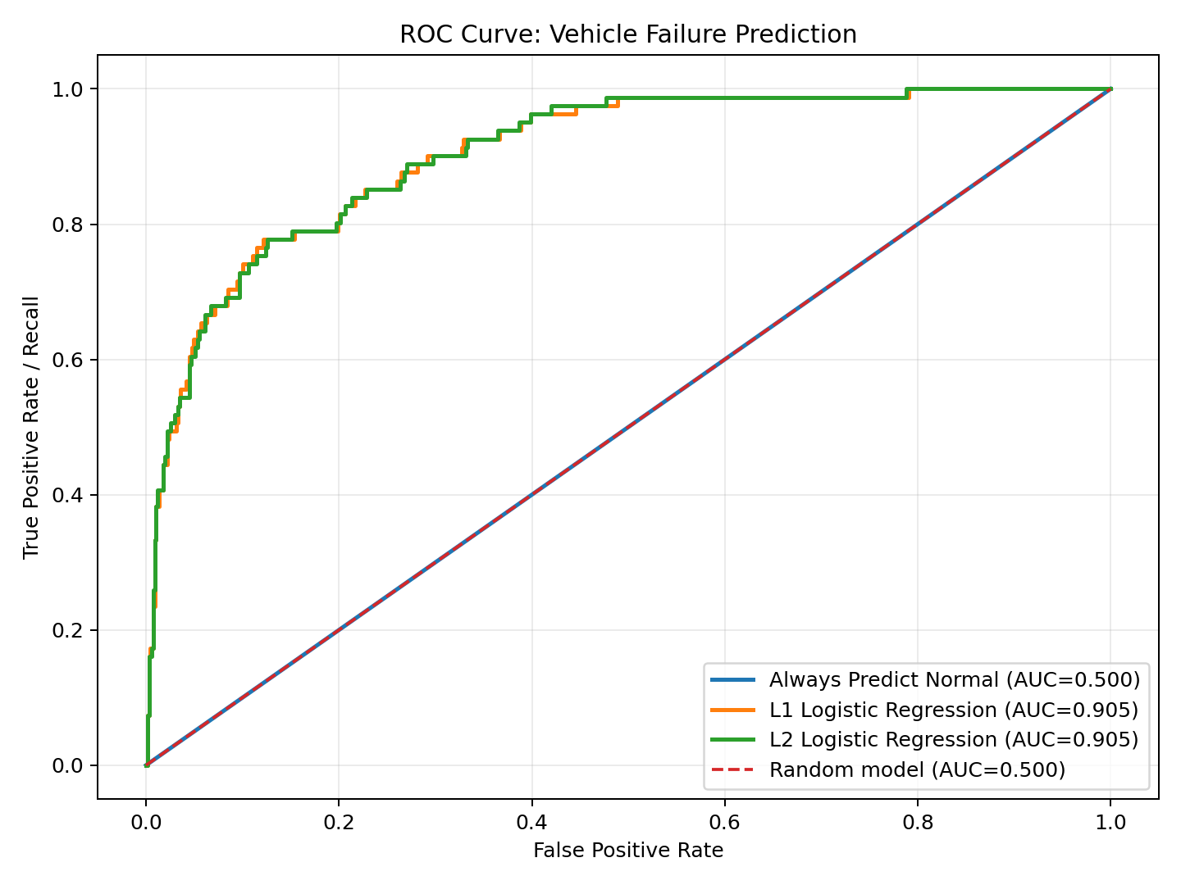
Figure 1. ROC curves for the all-normal baseline, L1 model, and L2 model. The diagonal represents random ranking.

5. Regularization (L1 and L2) - 5W1H
Regularization adds a penalty to the model-training objective. The penalty discourages excessively large coefficients and can improve generalization on unseen data.
5W1H question | Concept explanation | Vehicle-failure interpretation
What? | A method that adds a complexity penalty to the training loss. | Prevents the risk model from depending too strongly on noisy sensor variables.
Why? | To reduce overfitting, improve stability, and control model complexity. | A stable model should work across new vehicles, service centres, and months—not only on the training sample.
Who? | ML engineers, statisticians, model validators, and teams using linear or neural models. | The predictive-maintenance team chooses regularization during model development.
When? | When many features exist, features are correlated, coefficients are unstable, or train performance is much better than validation performance. | Use it when telematics and sensor features overlap or when new features are continuously added.
Where? | Logistic regression, linear regression, support vector machines, and neural networks. | Used inside the vehicle-failure logistic regression pipeline.
How? | Optimize prediction loss plus a penalty. L1 uses absolute coefficient values; L2 uses squared coefficient values. | L1 can remove weak signals by setting coefficients to zero; L2 keeps features but shrinks their influence.

5.1 L1 and L2 Comparison
Aspect | L1 regularization (Lasso-style) | L2 regularization (Ridge-style)
Penalty | Loss + lambda × sum(|coefficient|) | Loss + lambda × sum(coefficient²)
Effect | Can drive some coefficients exactly to zero. | Usually shrinks coefficients toward zero but retains them.
Feature selection | Provides embedded sparse feature selection. | Does not normally remove features completely.
Correlated features | May select one and suppress others; selection can vary. | Spreads weight more smoothly among correlated features.
Best use | Many features, need simpler explanation, suspect irrelevant variables. | Most features may contribute and stable smooth shrinkage is preferred.
Risk | Too-strong L1 can remove useful signals. | Too-strong L2 can underfit by shrinking all signals too much.

5.2 Understanding C in scikit-learn
C is inverse regularization strength
A smaller C means stronger regularization. A larger C means weaker regularization. For example, C=0.05 applies stronger shrinkage than C=1.0. C must be chosen through cross-validation rather than guessed from training accuracy.

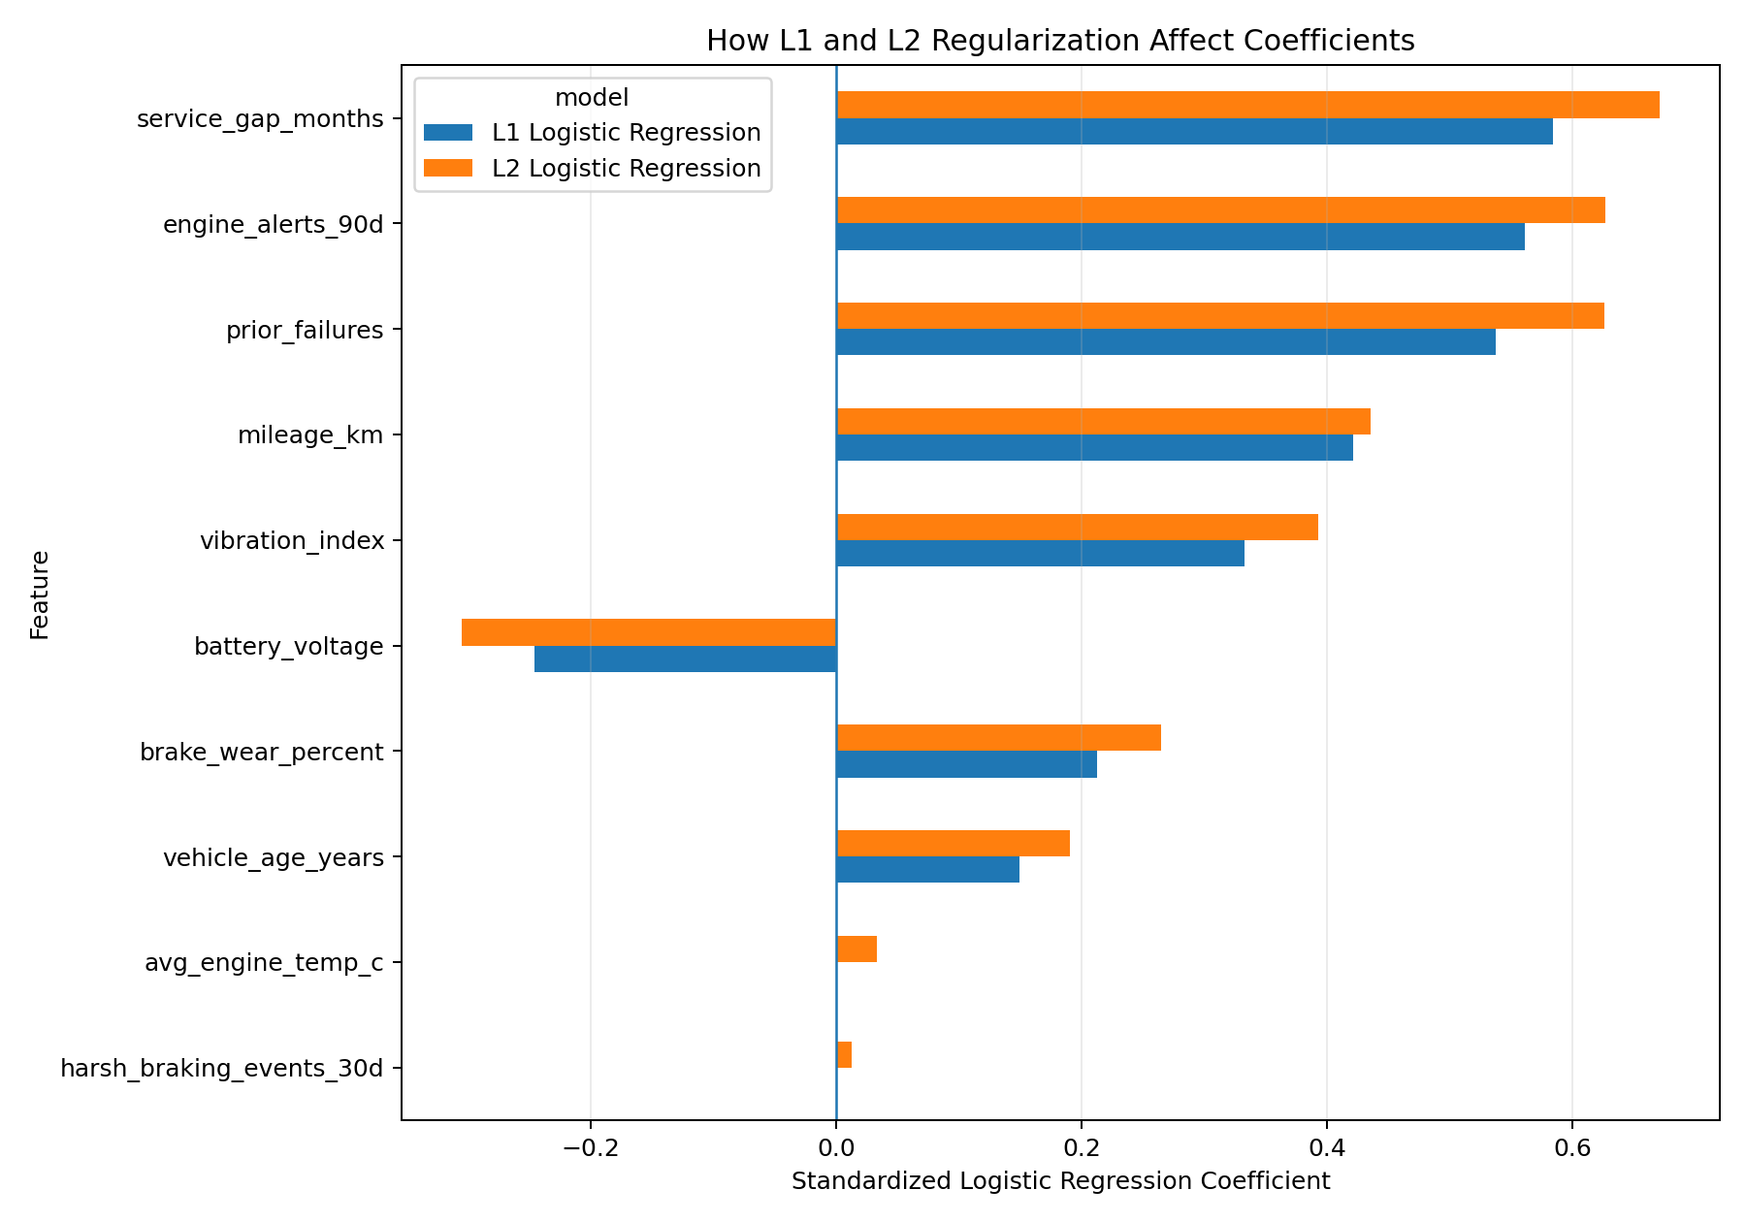
Figure 2. L1 sets two weak coefficients to zero in this run, while L2 keeps small non-zero contributions.

6. Cross-Validation - 5W1H
Cross-validation repeatedly trains and validates the model on different subsets of the available development data. It estimates both average performance and performance variability.
5W1H question | Concept explanation | Vehicle-failure interpretation
What? | A resampling method that creates multiple train-validation combinations. | Tests whether the failure model performs consistently across different vehicle samples or time periods.
Why? | One train-test split may be unusually easy or difficult. Cross-validation provides a more reliable estimate. | Avoids approving a model based on one lucky split.
Who? | Model developers, validators, researchers, auditors, and governance teams. | The ML team runs it; safety and maintenance owners review the mean and variability.
When? | During model selection, feature selection, regularization tuning, and hyperparameter tuning. | Before selecting L1/L2 and before final evaluation on a locked test set.
Where? | Any predictive modelling project, with a strategy matching the data structure. | Fleet data may require stratified, grouped, or chronological splitting.
How? | Split data into folds, train on several folds, validate on the remaining fold, repeat, and aggregate the metric. | Compute ROC-AUC in each fold and inspect mean, standard deviation, minimum, and maximum.

6.1 Cross-Validation Strategy Selection
Strategy | How it works | Use when | Main caution
K-Fold | Divides data into K folds; each fold is validation once. | Balanced, independent, non-ordered records. | Ordinary K-Fold may create uneven class ratios.
Stratified K-Fold | Preserves target-class proportion in each fold. | Imbalanced classification such as failure prediction. | Does not prevent the same vehicle appearing in train and validation.
Repeated Stratified K-Fold | Repeats stratified K-Fold with different splits. | Need a more stable estimate of mean and variance. | More computation and still assumes independent records.
Group K-Fold | Keeps all records from one group in the same fold. | Multiple inspections belong to the same vehicle, customer, factory, or driver. | Class balance may vary across folds.
TimeSeriesSplit | Trains on earlier records and validates on later records. | Future deployment must be simulated and temporal drift matters. | Do not shuffle; early folds have less training data.
Leave-One-Out | Uses one record for validation and all others for training. | Very small datasets and inexpensive models. | Expensive and often high-variance.
Nested CV | Outer CV estimates performance; inner CV tunes parameters. | Need an unbiased estimate after extensive tuning. | Computationally expensive but strongest for formal evaluation.

Data leakage rule
The validation split must reproduce the real deployment boundary. If the same vehicle appears in both training and validation, or if future records train a model evaluated on the past, the result may be unrealistically optimistic.

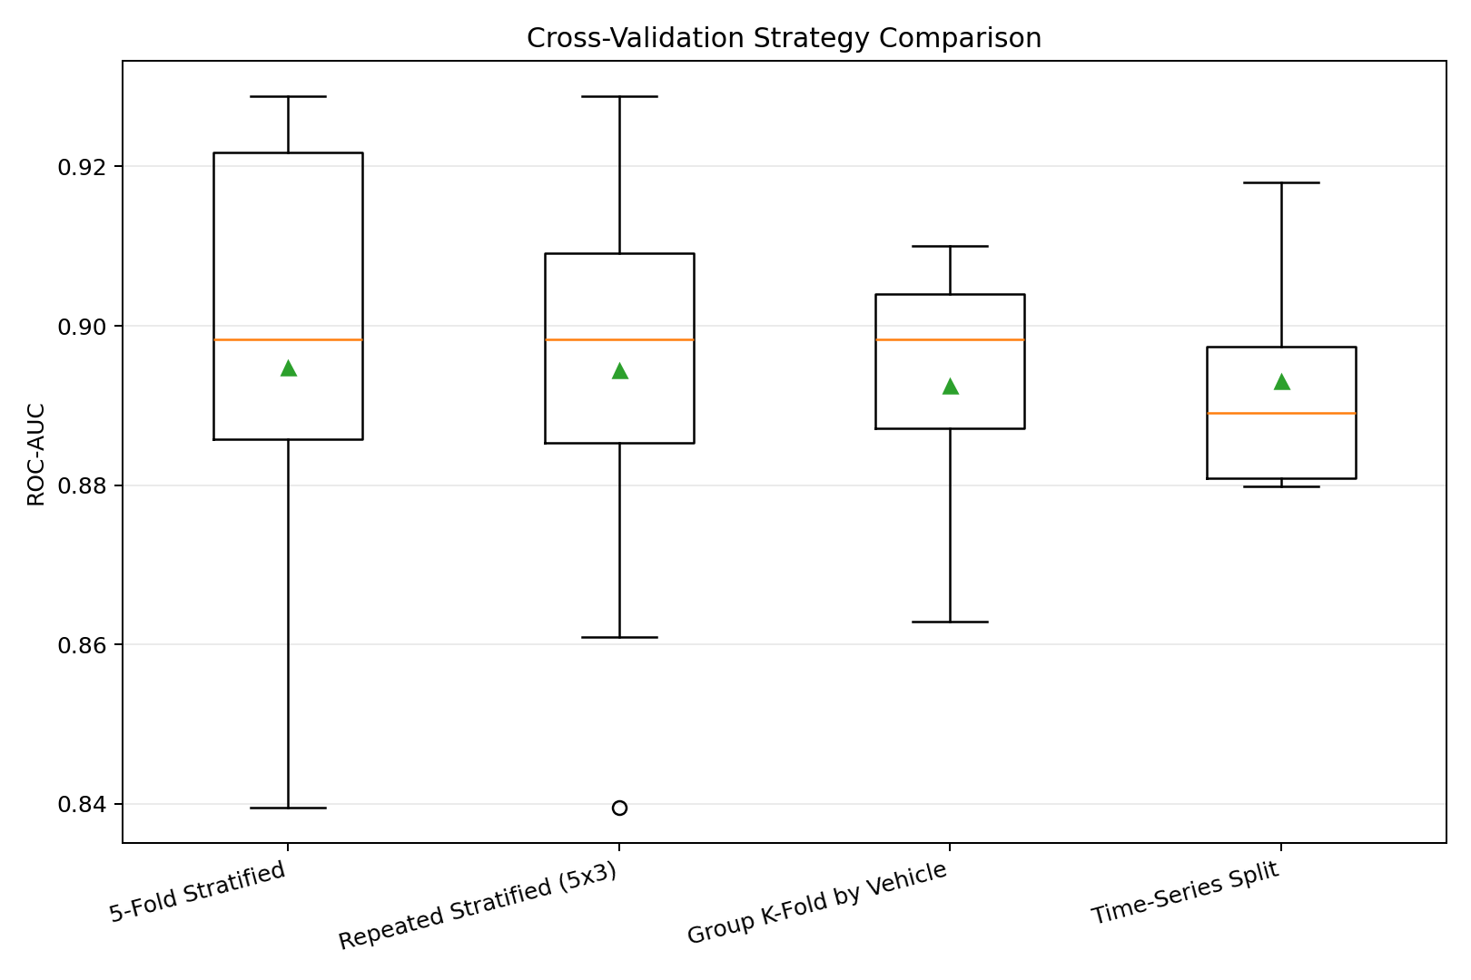
Figure 3. ROC-AUC distributions across stratified, repeated, grouped, and time-series validation strategies.

7. Integrated Case Study: Vehicle Failure Prediction

7.1 Business Problem
A commercial fleet wants to identify vehicles likely to experience a significant component failure within the next 30 days. Risky vehicles are sent for preventive inspection; vehicles predicted as normal continue operating.
Business item | Case-study definition
Primary goal | Rank vehicles by failure risk and detect as many real failures as practical.
Positive class | 1 = vehicle fails within the next 30 days.
Negative class | 0 = no failure within the next 30 days.
Critical error | False Negative: risky vehicle predicted as normal.
Operational error | False Positive: normal vehicle sent for unnecessary inspection.
Model output | Failure probability between 0 and 1.
Decision | Select a threshold based on safety capacity and inspection cost.

7.2 Dataset
The supplied program generates 3,000 synthetic inspection records. The failure rate is approximately 10.8%, creating an imbalanced classification problem in which an all-normal model can appear accurate.
Field | Meaning | Why it may matter
vehicle_age_years | Vehicle age in years | Older components may be more failure-prone.
mileage_km | Total distance travelled | Higher mileage increases cumulative wear.
service_gap_months | Months since last service | Longer service gaps can increase risk.
brake_wear_percent | Estimated brake wear | High wear may indicate urgent maintenance.
engine_alerts_90d | Engine alerts in previous 90 days | Repeated alerts indicate abnormal behaviour.
vibration_index | Aggregated vibration score | May signal mechanical deterioration.
battery_voltage | Measured battery voltage | Low voltage can indicate battery or charging issues.
avg_engine_temp_c | Average engine temperature | High temperature may indicate cooling or engine problems.
prior_failures | Previous component failures | Historical failure is a risk signal.
harsh_braking_events_30d | Harsh-braking events in 30 days | May increase wear and maintenance needs.
failure_next_30_days | Target: 0 or 1 | Indicates actual outcome.

7.3 Why Accuracy Fails as the Only Metric
In the holdout test set, 750 vehicles are evaluated. The all-normal baseline achieves 89.2% accuracy because most vehicles are normal. However, it identifies none of the 81 actual failures.
Model | Accuracy | Recall for failure | ROC-AUC | Failures missed
Always predict normal | 89.2% | 0.0% | 0.500 | 81 of 81

Training message
A model can have high accuracy and zero operational value for the minority class. The all-normal model has 89.2% accuracy, but 0% failure recall and AUC 0.50.

8. Step-by-Step Solution
- Generate or load the inspection dataset and inspect the target distribution.
- Separate input features X from the target y. Exclude identifiers, dates, and any hidden target-generation field.
- Create a stratified train-test split so both sets retain a similar failure proportion.
- Build a Pipeline containing StandardScaler and LogisticRegression to prevent preprocessing leakage.
- Train one L1 model and one L2 model.
- Use predict_proba to obtain risk scores; calculate ROC-AUC and draw ROC curves.
- Evaluate a chosen threshold using confusion matrix, precision, recall, and F1-score.
- Use cross-validation to test average AUC and variability under realistic split strategies.
- Select a threshold with maintenance and safety stakeholders.
- Lock the final test set, document results, deploy, and monitor drift and false-negative rate.

8.1 Leakage-Safe Pipeline
from sklearn.pipeline import Pipeline
from sklearn.preprocessing import StandardScaler
from sklearn.linear_model import LogisticRegression
l2_model = Pipeline([
("scale", StandardScaler()),
("model", LogisticRegression(
penalty="l2",
C=1.0,
class_weight="balanced",
max_iter=3000,
random_state=42
))
])

Why use a Pipeline? During each cross-validation fold, the scaler is fitted only on that fold’s training portion. Fitting StandardScaler on the full dataset before cross-validation would leak validation information into training.

8.2 ROC-AUC Calculation
from sklearn.metrics import roc_curve, roc_auc_score
l2_model.fit(X_train, y_train)
risk_probability = l2_model.predict_proba(X_test)[:, 1]
auc_value = roc_auc_score(y_test, risk_probability)
fpr, tpr, thresholds = roc_curve(y_test, risk_probability)

predict_proba returns two columns: probability of class 0 and probability of class 1. [:, 1] selects the failure probability, which is required for ROC-AUC.

8.3 L1 and L2 Setup
l1_model = LogisticRegression(
penalty="l1", solver="liblinear", C=0.05,
class_weight="balanced", max_iter=3000
)
l2_model = LogisticRegression(
penalty="l2", solver="lbfgs", C=1.0,
class_weight="balanced", max_iter=3000
)

The case study uses stronger regularization for L1 to make sparsity visible. In a production project, both the penalty type and C value must be selected through cross-validation, ideally in an inner tuning loop.

8.4 Cross-Validation Setup
from sklearn.model_selection import (
StratifiedKFold, RepeatedStratifiedKFold,
GroupKFold, TimeSeriesSplit, cross_val_score
)
stratified_cv = StratifiedKFold(
n_splits=5, shuffle=True, random_state=42
)
auc_scores = cross_val_score(
l2_model, X, y, cv=stratified_cv, scoring="roc_auc"
)

Use GroupKFold when repeated records belong to the same vehicle. Use TimeSeriesSplit when the model will be trained on past inspections and deployed on future inspections.

9. Holdout Test Results
Model | Accuracy | Precision | Recall | F1 | ROC-AUC | FP | FN
Always Predict Normal | 89.2% | 0.0% | 0.0% | 0.000 | 0.500 | 0 | 81
L1 Logistic Regression | 79.6% | 32.4% | 81.5% | 0.463 | 0.905 | 138 | 15
L2 Logistic Regression | 80.1% | 32.8% | 80.2% | 0.466 | 0.905 | 133 | 16

9.1 Interpretation
- The all-normal baseline has the highest accuracy (89.2%) but misses all failures and has AUC 0.50.
- The L1 and L2 models achieve ROC-AUC of about 0.905, indicating excellent ranking performance in this synthetic dataset.
- At threshold 0.50, the L2 model detects about 80.2% of failures but has precision of about 32.8%.
- The low precision is a consequence of the imbalanced problem and class weighting: the model intentionally produces more alerts to reduce missed failures.
- L1 and L2 perform similarly; L1 provides a sparser explanation, while L2 provides smoother coefficient shrinkage.

9.2 L2 Confusion Matrix at Threshold 0.50
Actual / Predicted | Predicted normal | Predicted failure
Actually normal | TN = 536 | FP = 133
Actually fails | FN = 16 | TP = 65

The model catches 65 of 81 failures and misses 16. It also sends 133 normal vehicles for unnecessary inspection.

10. Threshold Analysis
Threshold | Precision | Recall | False positives | False negatives | True positives
0.30 | 25.3% | 90.1% | 216 | 8 | 73
0.40 | 29.4% | 85.2% | 166 | 12 | 69
0.50 | 32.8% | 80.2% | 133 | 16 | 65
0.60 | 39.1% | 77.8% | 98 | 18 | 63
0.70 | 45.8% | 74.1% | 71 | 21 | 60

Business decision example
At threshold 0.30, recall rises to about 90.1% and only 8 failures are missed, but 216 normal vehicles are flagged. At threshold 0.70, false positives fall to 71, but 21 failures are missed. The safest threshold depends on inspection capacity and the cost of a missed failure.

11. Cross-Validation Results
Strategy | Scores | Mean AUC | Std AUC | Min | Max
5-Fold Stratified | 5 | 0.895 | 0.032 | 0.840 | 0.929
Repeated Stratified (5x3) | 15 | 0.894 | 0.022 | 0.840 | 0.929
Group K-Fold by Vehicle | 5 | 0.892 | 0.017 | 0.863 | 0.910
Time-Series Split | 5 | 0.893 | 0.014 | 0.880 | 0.918

- The mean AUC remains near 0.89 across all demonstrated strategies, suggesting stable ranking performance.
- Repeated Stratified K-Fold produces more validation scores and a more reliable view of variability.
- Group K-Fold is important when one vehicle has multiple records because it prevents entity leakage.
- Time-Series Split is the best deployment simulation when the business trains on historical data and predicts future failures.
- Do not automatically select the strategy with the highest mean. Select the strategy that best matches deployment reality.

12. Recommended Model and Deployment Decision
Decision area | Recommendation | Reason
Model family | Use L2 logistic regression as the initial production candidate. | L1 and L2 have almost identical AUC; L2 is stable with correlated predictors.
Alternative | Use L1 when a smaller feature set and simpler explanation are priorities. | L1 removes weak coefficients and can support feature reduction.
Validation | Use TimeSeriesSplit for future-period simulation and Group K-Fold when vehicles repeat. | Prevents temporal and entity leakage.
Threshold | Start review near 0.30-0.50; finalize through cost and capacity analysis. | Safety may justify more inspections to reduce false negatives.
Primary monitoring | Failure recall, false negatives, ROC-AUC, precision, alert volume, and calibration. | AUC alone does not describe threshold-level safety.
Retraining trigger | Monitor data drift, sensor changes, seasonal conditions, and performance decay. | Vehicle usage and environmental conditions change over time.

13. Production Checklist
- Keep a final test set untouched until model and threshold decisions are complete.
- Fit all preprocessing only inside the training pipeline.
- Prevent the same vehicle or fleet from leaking across train and validation folds.
- Use chronological validation when future prediction is the deployment scenario.
- Document the business cost of False Negative and False Positive errors.
- Evaluate probability calibration before using probabilities as expected risk.
- Review performance separately by vehicle model, geography, climate, age band, and usage type.
- Define alert capacity and escalation rules before selecting the threshold.
- Monitor performance after deployment and compare predicted risk with actual failures.

14. Learner Exercises
Exercise | Task
1. Accuracy trap | Explain why the all-normal model has 89.2% accuracy but should be rejected.
2. Threshold choice | Choose between threshold 0.30 and 0.70 for brake-failure screening and justify the decision.
3. L1 vs L2 | Explain why L1 sets some coefficients to zero and when that is useful.
4. Validation strategy | Select a strategy when each vehicle has 12 monthly records.
5. Time leakage | Explain why randomly shuffling three years of inspections may overstate future performance.
6. Code modification | Test C values [0.01, 0.05, 0.1, 1, 10] and compare mean cross-validated AUC and zero coefficients.
7. Advanced | Add a Precision-Recall curve and compare conclusions with ROC-AUC.

15. Suggested Answers
- Exercise 1: It predicts the majority class only, misses every failure, has zero failure recall, and AUC 0.50.
- Exercise 2: For safety-critical screening, 0.30 is likely preferable because it misses fewer failures, provided the inspection team can handle the additional false positives.
- Exercise 3: L1 uses an absolute-value penalty with a geometry that can produce exact zeros; this supports sparse models and embedded feature selection.
- Exercise 4: Group K-Fold or Stratified Group K-Fold is appropriate because all records from a vehicle should remain in one fold. If deployment is future prediction, also perform chronological evaluation.
- Exercise 5: Random shuffling lets future patterns influence training for records evaluated as if they were earlier, hiding temporal drift.

16. Files Included in the Package
File | Purpose
ROC_AUC_Regularization_CrossValidation_5W1H_Case_Study.docx | Concept notes, 5W1H, case study, results, and exercises.
roc_auc_regularization_cv_vehicle_case_study.py | Complete runnable Python solution.
vehicle_failure_ml_dataset.csv | Synthetic 3,000-record dataset.
model_results.csv | Holdout model comparison.
cross_validation_results.csv | Cross-validation strategy results.
threshold_analysis.csv | Threshold-level precision, recall, FP, and FN.
roc_curve_comparison.png | ROC plot.
regularization_coefficients.png | L1/L2 coefficient comparison.
cross_validation_auc.png | Cross-validation score distribution.

17. Run Instructions
pip install numpy pandas matplotlib scikit-learn
python roc_auc_regularization_cv_vehicle_case_study.py

The script regenerates the dataset, trains the models, prints evaluation results, and saves all charts and CSV result files in the same directory.

